The Advent Wreath
Its Tradition & Symbolism
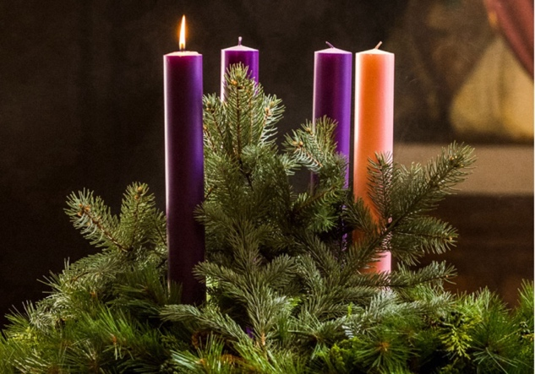

The origins of the Advent wreath are obscure. Historians agree that it originated in other contexts in Europe and probably pre-dates the birth of the baby Jesus. Pagans brought the tradition with them when they were baptized. The word “advent” itself derives from the Latin, adventus, which means “coming.” In our Christian context, of course, it refers to our penitent yet joyous preparation for the coming of our Blessed Lord, for the season of Christmas.

The wreath celebrates the beginning of the liturgical year. It also overflows with Christian symbols. For example, the circle represents the eternal nature of God and of His love; the evergreens symbolize eternal life; the laurel, victory over suffering and death; the yew and pine, immortality. Holly has special significance: the prickly leaves signify the crown of thorns that awaits the Blessed Baby. It is also said that the Cross on which Christ would hang was made of holly. Pinecones and seed pods hold the promise of our new life in Christ.

There is one candle for each of the four weeks of Advent. The three purple candles (and the purple ribbon) are for penance while one rose candle is for Rose Sunday. It reminds us that we
are halfway through this somber season of expectancy. It also tells us to rejoice because the Lord is at hand.

Lighting the Candles
Arrangements for who lights the candles will vary according to the family make-up and number of children. Most common is for the father to light the first candle on the first Sunday. On the second Sunday the mother lights the first and second candles; on the third Sunday the oldest child lights the first, second, and third candles; and on the fourth Sunday the youngest child lights all four candles. Now all the candles shed their brilliance to announce the approaching nativity of our Lord.

A very practical custom is to make the evening meal each day the time for the candle lighting ceremony, allowing the candles to burn until after the meal. Or the prayers at the wreath may be used as family prayers at bedtime each evening. During the twelve days of Christmas (December 25 – January 6) the
purple candles and ribbon may be replaced with white ones, and all four candles may be lit at mealtime or during family prayers. Bright Christmas balls may also be added to the wreath during the Christmas season.

Liturgy for Lighting the Candles
A member of the family lights one or more candles of the Advent wreath, depending on the Sunday in Advent.

Leader: Grace to you and peace from God our Father and the Lord Jesus Christ.

All: Come, Lord Jesus!

Leader reads Scripture passage for the day (see list below) and concludes with “Here endeth the lesson.”

All: Thanks be to God.

Blessing of the Advent Wreath
On the first Sunday in Advent the leader asks God’s blessing on the wreath with the following words:

Leader: O Lord, by Whose Word all things are sanctified; pour forth Thy blessings upon this wreath of green, and grant that we who use it may prepare our hearts for the coming of Christ, and may receive Thy abundant grace, through Jesus Christ our Lord. Amen

Leader: Let us pray.

The leader reads the collect for the week. See following page.

All: Visit, O Lord, this habitation and this family; drive far from it all snares of the enemy, let Thy holy angels dwell herein to preserve us in peace, and let Thy blessing be ever upon us, through Jesus Christ our Lord. Amen.

Leader: The almighty and merciful Lord, Father, Son, and Holy Ghost, bless us and keep us. Amen

At the end of the meal all of the candles are extinguished.

Suggested Scripture Readings

Day Week One Week Two Week Three Week Four
Sun John 1:9-14 Isaiah 40:1-12 Isaiah 9:6-7 Luke 1:5-25
Mon John 3:16-21 Genesis 3:1-21 Isaiah 7:10-16 Luke 1:26-36
Tue Isaiah 60:1-3 Micah 5:1-3 Isaiah 11:1-6 Luke 1:39-56
Wed Psalm 43:3-5 Hosea 11:3-4 Isaiah 40:9-11 Luke 1:57-66
Thur Isaiah 58:6-9 Psalm 130 Isaiah 52:7-12 Luke 1:67-80
Fri I John 2:8-11 Micah 6:6-8 Jeremiah 33:14-16 Jeremiah 23:5-8
Sat I John 3:1-2,7-10 Jeremiah 14:7-9 Matthew 3:1-6 Matthew 1:18-25

The Collects of Advent
First Sunday in Advent
Almighty God, give us grace that we may cast away the works of darkness, and put upon us the armour of light, now in the time of this mortal life, in which thy Son Jesus Christ came to visit us in great humility; that in the last day, when he shall come again in his glorious majesty to judge both the quick and the dead, we may rise to the life immortal, through him who liveth and reigneth with thee and the Holy Ghost, now and ever. Amen

This Collect is to be repeated every day, after the other Collects in Advent, until Christmas Day.

Second Sunday in Advent
Blessed Lord, who has caused all Holy Scriptures to be written for our learning: Grant that we may in such wise hear them, read, mark, learn, and inwardly digest them, that by patience and comfort of thy Holy Word, we may embrace, and never hold fast, the blessed hope of everlasting life, which thou hast
given us in our Saviour Jesus Christ. Amen.

Third Sunday in Advent
O Lord Jesus Christ, who at thy first coming didst send thy messenger to prepare thy way before thee; grant that the ministers and stewards of thy mysteries may likewise so prepare and make ready thy way, by turning the hearts of the disobedient to the wisdom of the just, that at thy second coming to judge the world we may be found an acceptable people in thy sight, who livest and reignest with the Father and the Holy Spirit ever, one God, world without end. Amen

Fourth Sunday in Advent
O Lord, raise up, we pray thee, thy power, and come among us, and with great might succor us; that whereas, through our sins and wickedness, we are sore let and hindered in running the race that is set before us, thy bountiful grace and mercy may speedily help and deliver us; through Jesus Christ our Lord, to whom, with thee and the Holy Ghost, be honour and glory, world without end. Amen

